Q1: What is the KNN Algorithm and what is “K” in the KNN Algorithm?

Q2: How does the KNN algorithm make the predictions on the unseen dataset?

Q3: Is Feature Scaling required for the KNN Algorithm?

Q4: Why is the KNN Algorithm known as Lazy Learner?

Q5: Why is it recommended not to use the KNN Algorithm for large datasets?

Q6: How to choose the optimal value of K in the KNN Algorithm?

Q7: Is it possible to use the KNN algorithm for Image processing?

Q8: What are the real-life applications of KNN Algorithms?

Q9: What are the advantages of the KNN Algorithm?

Q10: What are the disadvantages of the KNN Algorithm?

Answers:

- KNN (K-nearest neighbours) is a supervised learning and non-parametric algorithm that can be used to solve both classification and regression problem statements.
It uses data in which there is a target column present, i.e, labelled data, to model a function to produce an output for the unseen data. It uses the euclidean distance formula to compute the distance between the data points for classification or prediction.
The main objective of this algorithm is that similar data points must be close to each other so it uses the distance to calculate the similar points that are close to each other.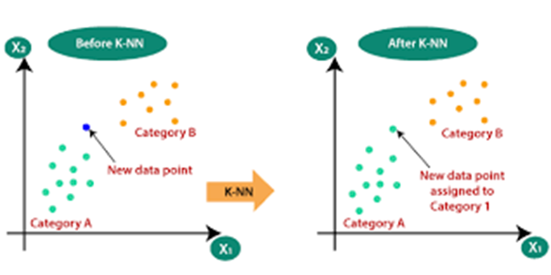
- The following operations have happened during each iteration of the algorithm. For each of the unseen or test data points, the kNN classifier must:
Step-1: Calculate the distances of test point to all points in the training set and store them
Step-2: Sort the calculated distances in increasing order
Step-3: Store the K nearest points from our training dataset
Step-4: Calculate the proportions of each class
Step-5: Assign the class with the highest proportion
- Yes, feature scaling is required to get the better performance of the KNN algorithm. For Example, Imagine a dataset having n number of instances and N number of features. There is one feature having values ranging between 0 and 1. Meanwhile, there is also a feature that varies from -999 to 999. When these values are substituted in the formula of Euclidean Distance, this will affect the performance by giving higher weightage to variables having a higher magnitude.
- When the KNN algorithm gets the training data, it does not learn and make a model, it just stores the data. Instead of finding any discriminative function with the help of the training data, it follows instance-based learning and also uses the training data when it actually needs to do some prediction on the unseen datasets.
As a result, KNN does not immediately learn a model, rather it delays the learning thereby being referred to as Lazy Learner.
- The Problem in processing the data:
KNN works well with smaller datasets because it is a lazy learner. It needs to store all the data and then make a decision only at run time. It includes the computation of distances for a given point with all other points. So if the dataset is large, there will be a lot of processing which may adversely impact the performance of the algorithm.
Sensitive to noise:
Another thing in the context of large datasets is that there is more likely a chance of noise in the dataset which adversely affects the performance of the KNN algorithm since the KNN algorithm is sensitive to the noise present in the dataset.
- There is no straightforward method to find the optimal value of K in the KNN algorithm.
You have to play around with different values to choose which value of K should be optimal for my problem statement. Choosing the right value of K is done through a process known as Hyperparameter Tuning.
The optimum value of K for KNN is highly dependent on the data itself. In different scenarios, the optimum K may vary. It is more or less a hit and trial method.
There is no one proper method of finding the K value in the KNN algorithm. No method is the rule of thumb but you should try the following suggestions:
1. Square Root Method: Take the square root of the number of samples in the training dataset and assign it to the K value.
2. Cross-Validation Method: We should also take the help of cross-validation to find out the optimal value of K in KNN. Start with the minimum value of k i.e, K=1, and run cross-validation, measure the accuracy, and keep repeating till the results become consistent.
As the value of K increases, the error usually goes down after each one-step increase in K, then stabilizes, and then raises again. Finally, pick the optimum K at the beginning of the stable zone. This technique is also known as the Elbow Method.
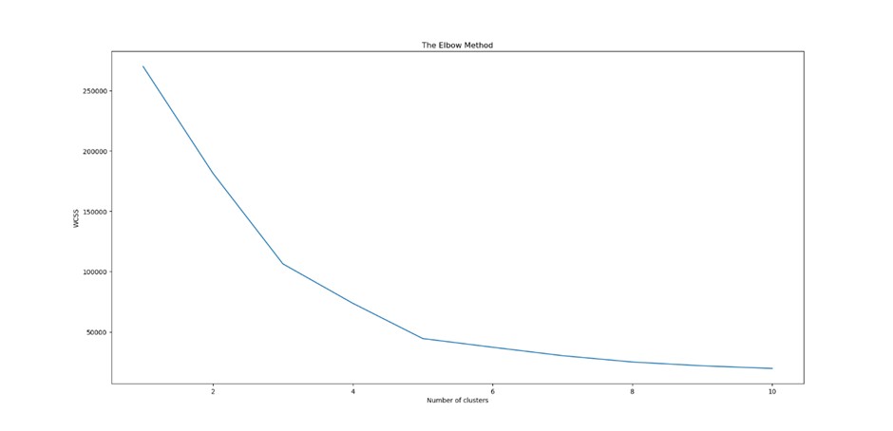
3. Domain Knowledge: Sometimes with the help of domain knowledge for a particular use case we are able to find the optimum value of K (K should be an odd number).
I would therefore suggest trying a mix of all the above points to reach any conclusion.

- Yes, KNN can be used for image processing by converting a 3-dimensional image into a single-dimensional vector and then using it as the input to the KNN algorithm. 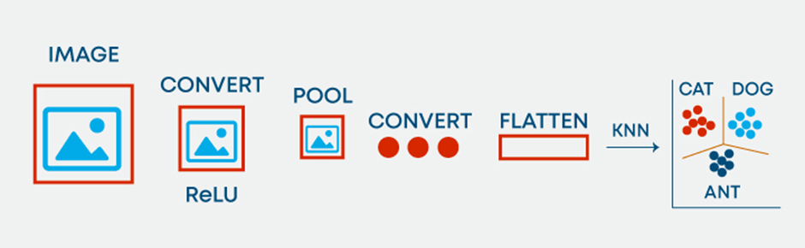
- The various real-life applications of the KNN Algorithm includes:
1. KNN allows the calculation of the credit rating. By collecting the financial characteristics vs. comparing people having similar financial features to a database we can calculate the same. Moreover, the very nature of a credit rating where people who have similar financial details would be given similar credit ratings also plays an important role. Hence the existing database can then be used to predict a new customer’s credit rating, without having to perform all the calculations.
2. In political science: KNN can also be used to predict whether a potential voter “will vote” or “will not vote”, or to “vote Democrat” or “vote Republican” in an election.
Apart from the above-mentioned use cases, KNN algorithms are also used for handwriting detection (like OCR), Image recognition, and video recognition.

- Some of the advantages of the KNN algorithm are as follows:
1. No Training Period: It does not learn anything during the training period since it does not find any discriminative function with the help of the training data. In simple words, actually, there is no training period for the KNN algorithm. It stores the training dataset and learns from it only when we use the algorithm for making the real-time predictions on the test dataset.
As a result, the KNN algorithm is much faster than other algorithms which require training. For Example, SupportVector Machines(SVMs), Linear Regression, etc.
Moreover, since the KNN algorithm does not require any training before making predictions, as a result new data can be added seamlessly without impacting the accuracy of the algorithm.
2. Easy to implement and understand: To implement the KNN algorithm, we need only two parameters i.e. the value of K and the distance metric(e.g. Euclidean or Manhattan, etc.). Since both the parameters are easily interpretable, therefore they are easy to understand.
- Some of the disadvantages of the KNN algorithm are as follows:
1. Does not work well with large datasets: In large datasets, the cost of calculating the distance between the new point and each existing point is huge which decreases the performance of the algorithm.
2. Does not work well with high dimensions: KNN algorithms generally do not work well with high dimensional data since, with the increasing number of dimensions, it becomes difficult to calculate the distance for each dimension.
3. Need feature scaling: We need to do feature scaling (standardization and normalization) on the dataset before feeding it to the KNN algorithm otherwise it may generate wrong predictions.
4. Sensitive to Noise and Outliers: KNN is highly sensitive to the noise present in the dataset and requires manual imputation of the missing values along with outlier removal.

